SMART HOME AUTOMATION

REQUIREMENTS:

Arduino UNO R3, Ultrasonic distance sensor, PIR sensor, Temperature sensor, DC motor, Photoresistor, breadboard small, Micro-servo, Piezo, Resistor, Slide switch, Light bulb, Power supply.

SOFTWARE REQUIRED:

Tinkercad Software

CODE:

#include<Servo.h>

int PIR = 8;

int LDR = A1;

int LED = 10;

int TMP = A0;

int MTR = 6;

int D;

int TRIG = 8;

int ECHO = 9;

int BUZZER = 5;

Servo door;

void setup()

{

door.attach(A2);

pinMode(LDR,INPUT);

pinMode(LED,OUTPUT);

pinMode(TMP,INPUT);

pinMode(MTR,OUTPUT);

pinMode(TRIG,OUTPUT);

pinMode(ECHO,INPUT);

pinMode(BUZZER,OUTPUT);

pinMode(2,OUTPUT);

pinMode(3,OUTPUT);

pinMode(4,OUTPUT);

pinMode(A1,OUTPUT);

Serial.begin(9600);

}

void loop()

{

int LDR2 = analogRead(LDR);

Serial.println(LDR2);

if(LDR2 <= 50)

{

digitalWrite(LED,HIGH);

digitalWrite(2,HIGH);

digitalWrite(3,HIGH);

digitalWrite(4,HIGH);

}

else

{

digitalWrite(LED,LOW);

digitalWrite(2,LOW);

digitalWrite(3,LOW);

digitalWrite(4,LOW);

}

int TEMP = analogRead(TMP);

float VOLT = TEMP\*5.0;

VOLT /= 1024.0;

float TempC = (VOLT - 0.5)\*100;

if(TempC >= 30)

{

digitalWrite(MTR,HIGH);

}

else

{

digitalWrite(MTR,LOW);

}

D = digitalRead(12);

if(D == 1)

{

door.write(100);

}

else

{

door.write(0);

}

long duration,distance;

digitalWrite(TRIG,HIGH);

delayMicroseconds(10);

digitalWrite(TRIG,LOW);

duration = pulseIn(ECHO,HIGH);

distance = duration/58.2;

if(distance <= 50 && distance >= 0)

{

digitalWrite(BUZZER,HIGH);

}

else

{

digitalWrite(BUZZER,LOW);

}

delay(60);

if(digitalRead(PIR) == HIGH)

{

digitalWrite(BUZZER,HIGH);

}

else

{

digitalWrite(BUZZER,LOW);

}}

CIRCUIT DIAGRAM:

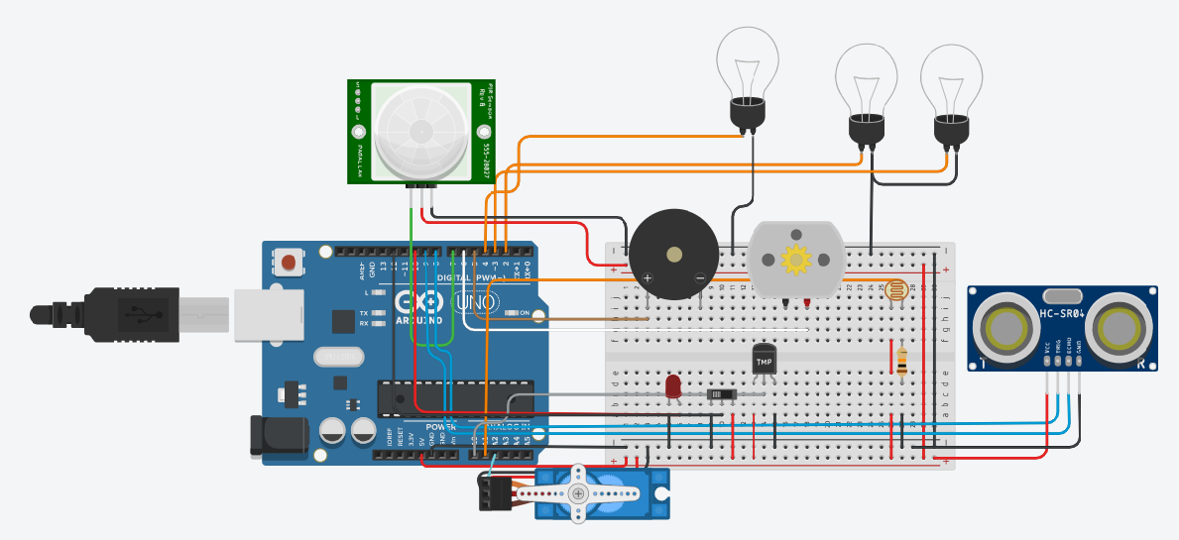

SCHEMATIC DIAGRAM:

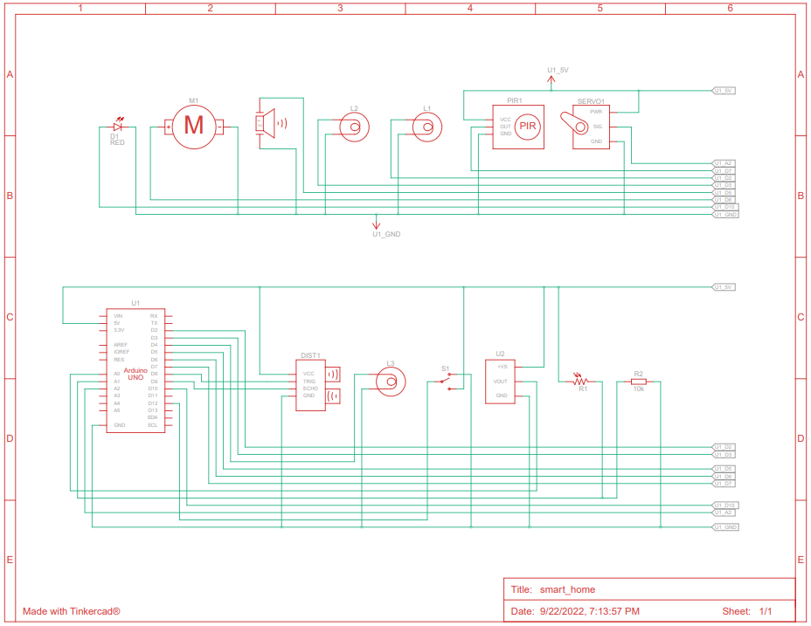

DEMO LINK:

https://www.tinkercad.com/things/cqQbalqCoT7-smarthome/editel